Supplementary Information for
SLGT11 Controls Floral Organ Identity and Floral Reversion in Tomato

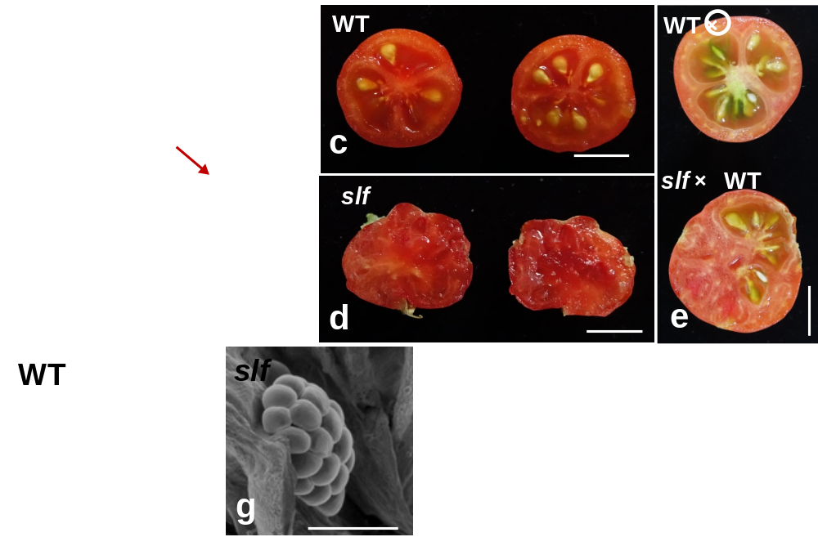

Fig. S1 Phenotype of ovary and fruit in WT and slf
The ovary of (a) WT and (b) slf, red arrow indicate the stamen fuse with ovary.
The crosscutting views of fruit show the seed production in WT (c) and slf (d) without pollination. The slf fruit forms seeds after cross-pollination (e bottom)
(f) SEM analysis the ovule in (f) WT and (g) slf.
Scale bars: (a and b) 1 mm; (c, d and e) 1cm; f and g 500 μm .

Fig. S2 Phylogenetic analysis of SLGT11 and its homologs.
The neighbor-joining phylogenetic tree of SLGT11 and 60 homologs that share high similarities with SLGT11 across different plants species. The abbreviations of species name and the gene bank ID is listed for each homology. SLGT11 and AtGT11 are marked in the green and red oval, respectively.

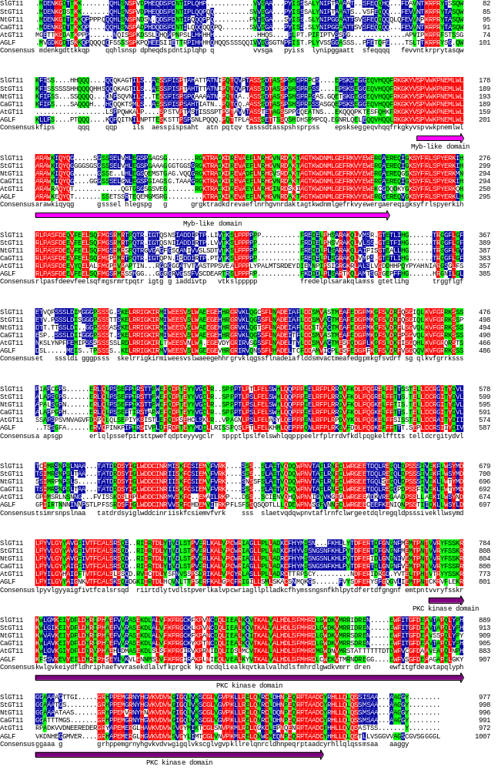
Fig. S3 Multiple alignment of SLGT11 and its homologs.
Multiple alignment of SLGT11 and five homologs from Solanum tuberosum L (StGT11), Nicotiana tabacum (NtGT11), Capsicum annuum L(CaAGLF), Medicago truncatula(AGLF), and Arabidopsis thaliana (AtGT11) carried out with DNAMAN. The MYB-like DNA binding domain is indicated by a pink underline; the partial kinase domain is indicated by a purple underline.

Name Primers Amplification
SLGT11-pro-F | ATAGAAAAGTTGGGTACCGAGTTGATGTTGAATCCTGAGTTCC | for clone of SLGT11's promoter
SLGT11-pro-R | GTATCTAGACTCGAGCTCTTCAATAAGGGCCCCAGAT
SLGT11-F | CATTTGGAGAGGACACGCTCGAGATGGATGAAACAAAGGAGA ACC | for clone of SLGT11
SLGT11-R | TCGCCCTTGCTCACCATGAATTCATACCCTCCGGCGGCGGCTG
SLGT11-m-F | GTCTATACCATGGTTCCCATG | for check mutations
SLGT11-m-R | ATGATTCGTTCCTGTGATCGACT
SLGT11-RNAi-F | CAAAAAAGCAGGCTCCACATGGACCTTCCTTACG | for Silence SLGT11
SLGT11-RNAi-R | CAAGAAAGCTGGGTCCGCTCAAAATCAGTGTAC
SLACTIN-qRT-FW | GTCCTCTTCCAGCCATCCAT | For internal qRT-PCR control in tomato
SLACTIN-qRT-RV | ACCACTGAGCACAATGTTACCG
SLGT11-qRT-F | TTTGCCTGTGGAGAGGAGAGGAAA | For SLGT11 qRT-PCR analysis
SLGT11-qRT-R | ACTCAACGCGCAGAACGTAACGAT
TAP3-qRT-Fw | CCTACTTTTGCTTAATCCAGTGTGT | For TAP3 qRT-PCR analysis
TAP3-qRT-Rv | ACATTTCCATACTTCCACATGATCT
TM6-qRT-Fw | CTACAACCATTGCACCCCAAT | For TM6 qRT-PCR analysis
TM6-qRT-Rv | CAGGAGAGACGTAGATCACGAGAA
TPI-qRT-Fw | GGAGATGGGAGCCATTGGTG | For TPI qRT-PCR analysis
TPI-qRT-Rv | CATTGGCTGAACTCGTAGGC
TPIB-qRT-Fw | TGAAATCAACAAAGTCAAGAAAGACA | For TPIB qRT-PCR analysis
TPIB-qRT-Rv | TTCACCCTTTAGGTGCCTGAGT
TAG1-qRT-Fw | CCTCCACCTCAGCAATTCGAT | For TAG1 qRT-PCR analysis
TAG1-qRT-Rv | ACTAGTTGAATAGGGGGTTGGTC
TM29-qRT-Fw | TCCTCAATCTCAGGGTTTC | For TM29 qRT-PCR analysis
TM29-qRT-Rv | GTTATTTGGCTTGAAGTTGT

Table S1. PCR primer sequences used in this study.

